Project Documantation

What software **Eng SE ?**

* state of the art of developing quality software on time and

within budget

* Trade-off between perfection and physical constraints
* SE has to deal with real-world issues
* State of the art!
* Community decides on best practice + life-long education

What are **SDLC & its rules?**

* For project development rules & regulation need to be followed for best quality output at defined time limit
* Rules are **Software Development Life Cycle – SDLC**
* It‘s part of software engineering
* Six rules to be followed…

Project Rules & Regulation (SDLC) Software deve life cycle

6 RULES

1. Requirement

1. Analysis

Requirement analysis

Time requirement

Budget

How many users

Step 1 : Find total no of user

Guest

Customer    ->  website

Admin -> admin panel                customer task & employee

Employee ->  employee panel    customer task manage

Step 2 : define each task of user

Guest

View categories

View Product

Contact us

Customer

View categories

View Product

Contact us

Signup

Login

Add to cart

Manage cart

Order

Manage order

Feedback

Logout

======================

Employee

Signup by admin

login

Manage categories    add/upd/del

Manage Product

Manage Contact us

Manage customer

View cart history

Manage Order

Logout

Admin

Login F

Manage categories F / T

Manage Product F / T

Manage user T

Manage Emp F / T

View Contact us T

View cart T

Manage Order T

Manage Feedback T

Logout

1. Step : 3 Define Diagram
2. Use case Diagram

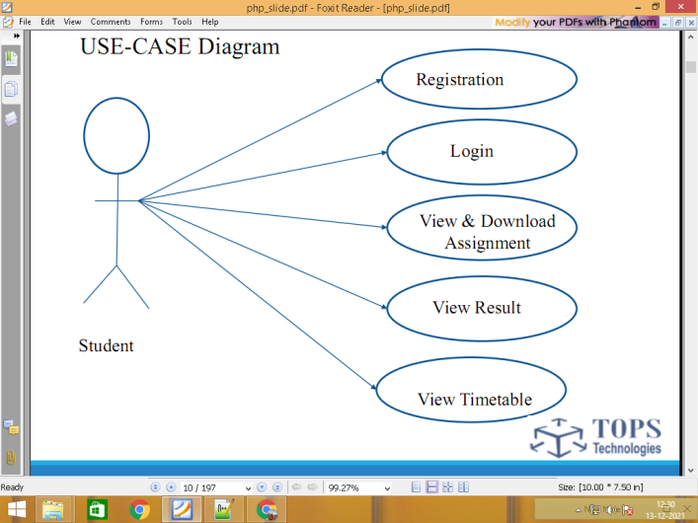

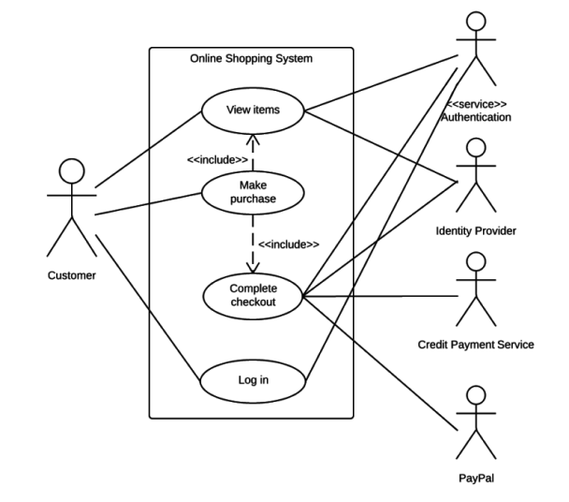

1. DFD Data flow diagram

0 level

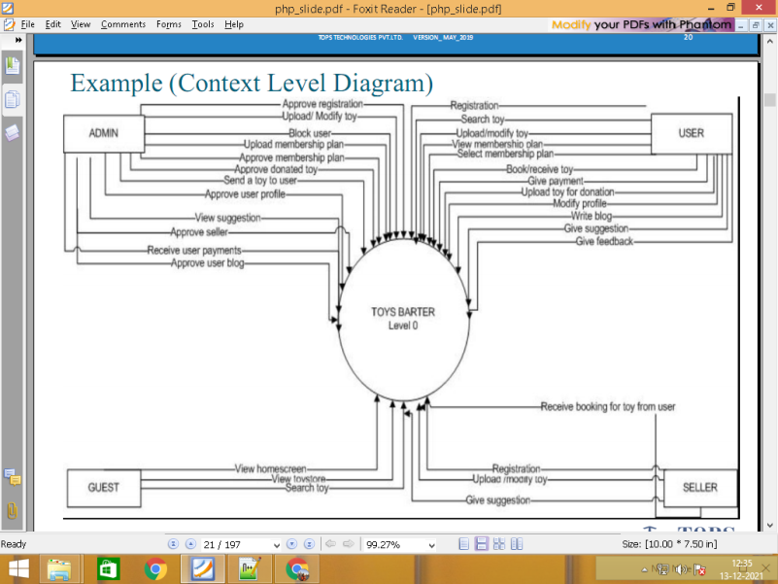

Level 1

\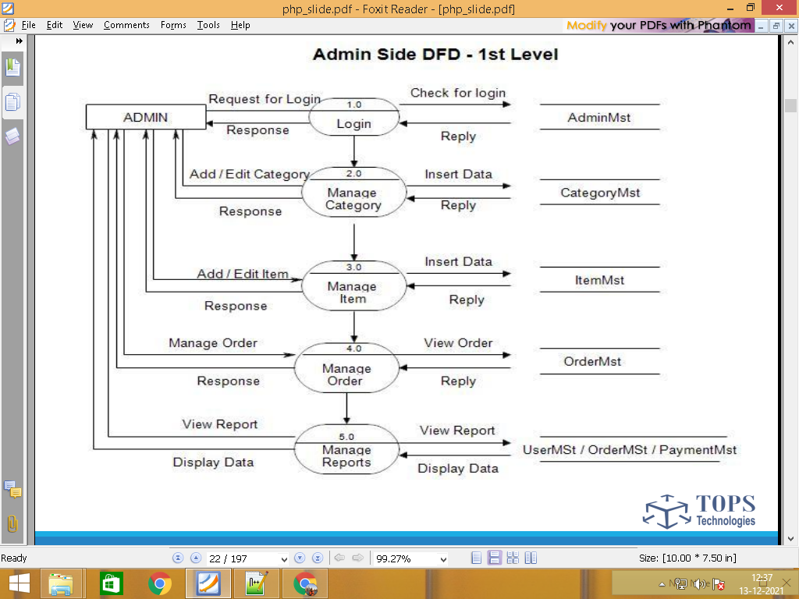

1. Define Database Table

Customer

View categories categories.tbl

View Product product.tbl

Contact us inquiry.tbl F

Signup customer.tbl F

Customer Login customer.tbl F

Add to cart cart.tbl

Manage cart cart.tbl T

Order order.tbl T

Manage order order.tbl

Feedback feedback.tbl F

Logout customer.tbl

======================

Employee

Login employee.tbl F

Manage categories    add/upd/del      categories.tbl F/T

Manage Product product.tbl F/T

Employee

Manage Contact us inquiry.tbl T

Manage customer customer.tbl T

View cart history cart.tbl T

Manage Order order.tbl T

Logout employee.tbl

Admin

**Login**  admin.tbl F

Manage categories    add/upd/del categories.tbl F/T

Manage Product product.tbl F/T

Manage Contact us inquiry.tbl T

Manage customer customer.tbl T

Admin

View cart history cart.tbl T

Manage Order order.tbl T

Manage Employee employee.tbl F/T

Manage Feedback feedback.tbl T

Logout admin

1. Find Total no of table

categories.tbl

product.tbl

inquiry.tbl

customer.tbl

cart.tbl

order.tbl

feedback.tbl

Employee.tbl

Admin.tbl

1. Find column of each table

Categories.tbl      table column 3 /  form  2

**Cate_id   PK  AI**

Cate_name

Cate_img

Product.tbl                       column     9 table  / form 7

**Prod_id   PK  AI**

Cate_id   FK

Prod_name

Short_dec

Prod_img

Main_price

Disc_price

qty

**Status             In stock / out of Stock**

Inquiry.tbl     t -4  f-3

**Inq_id  PK AI**

Name

Email

Comment

customer.tbl

**Cust_id  PK AI**

Name

Email

Password

Mobile

Img

**Status                  Unblock/Block**

cart.tbl

**Cart_id   PK AI**

**Prod_id  fk**

**Cust_id  fk**

**Qty**

**===================================================**

**Start Create DATABASE AND TABLE**

**Data Dictionary**

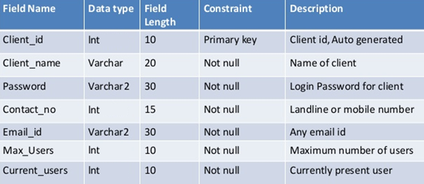

1. **Designing / Database**

**4) Coding / implementation**

**5) Testing**

1. **Maintenance**

**====================================================================**

**Website Panel : Customer / Guest**

**Admin Panel : Admin**

**Employee Panel : Employee**

===============================================================================

Admin/Backend Panel Pge List

**Login**

**Dashboard**

**Add Product / Form**

**Manage Products / Table**

================================================================